**Create a GitHub account.**

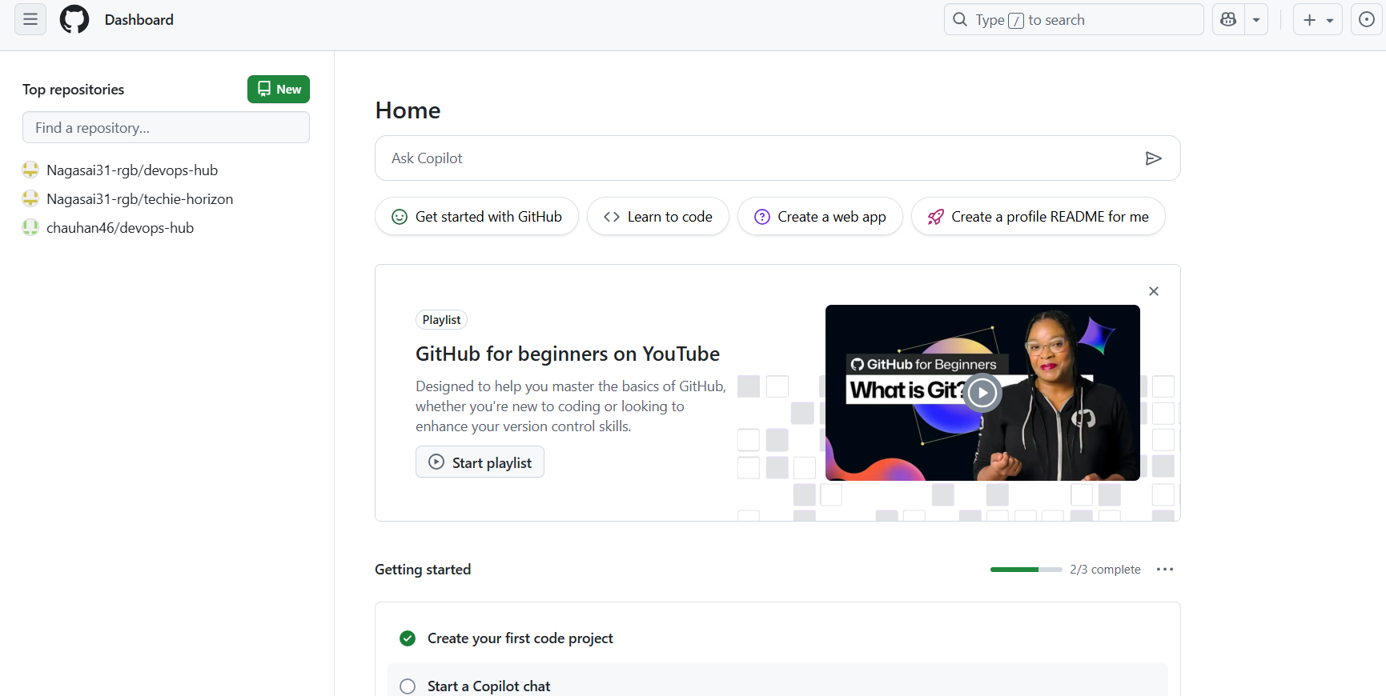

**Set-up MFA For Git Hub Using Mobile App**

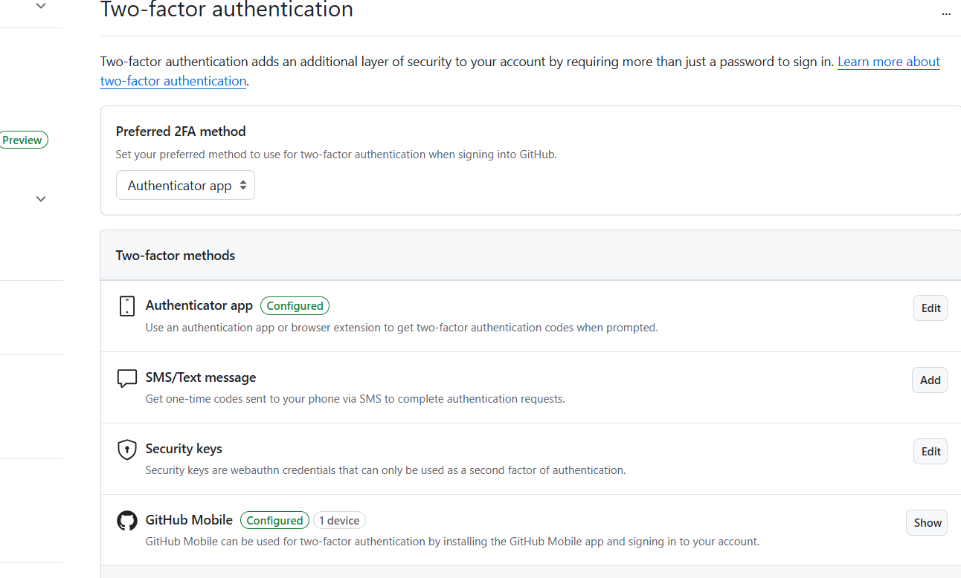

**Execute some commands**

1. **GIT –VERSION**

* check the version of the git

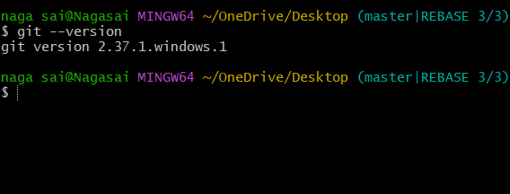

**2.Git init**

It initializes a new Git repository in your current directory

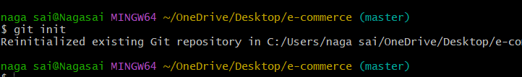

**3.Git config**

**\* Git config - -list to see the configuration of the git**

**\* You can also see your user’s name and email you provided.**

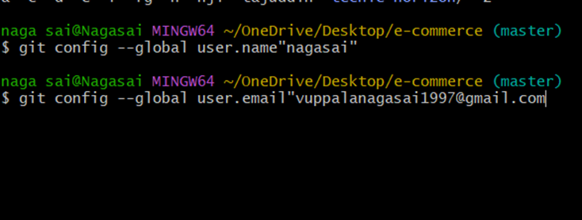

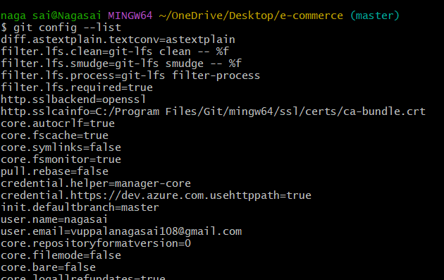

**4.Git status**

**\* check the status of your current directory**

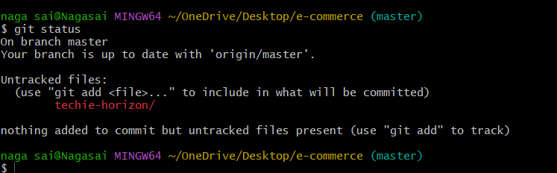

**5.** Git Add

**\* Add a new file to the directory**

**6.Git commit -m ‘’message”**

*store a copy in your machine

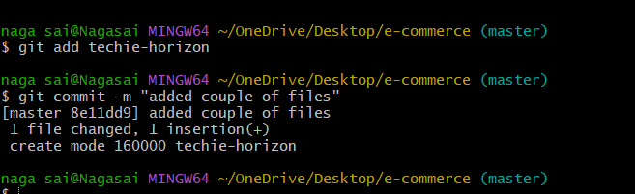

**7. Git log**

**\* print all the logs**

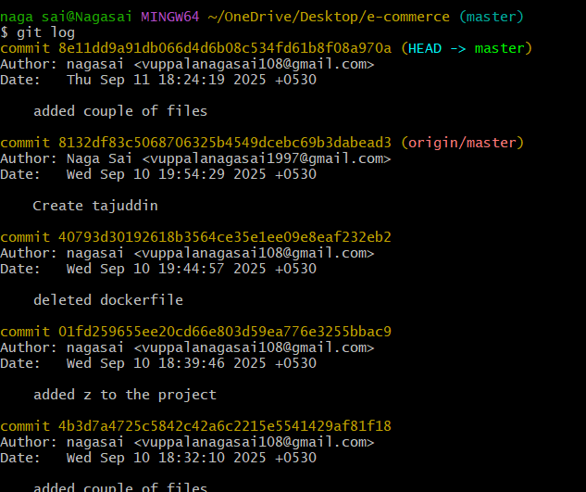

**8.ssh-keygen**

* **Go to git hub create new repository to push all the files to repository.**
* **Git remote -v : address had been configured or not**
* **Gir remote add origin “url” : to get remote access to the central repository.**

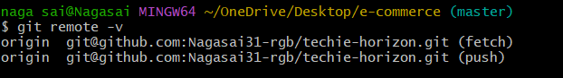

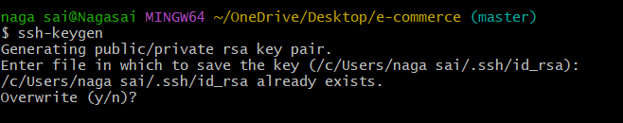

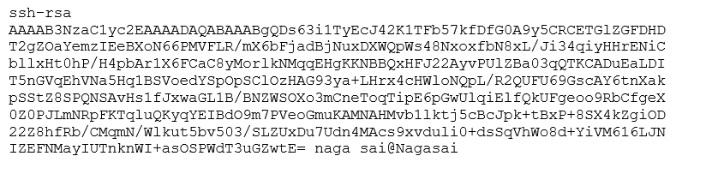

**Copy the key**

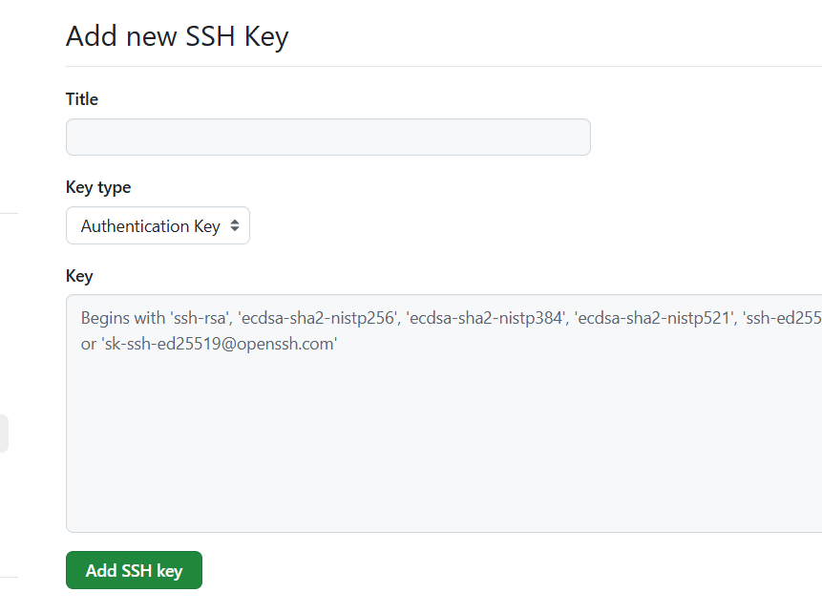

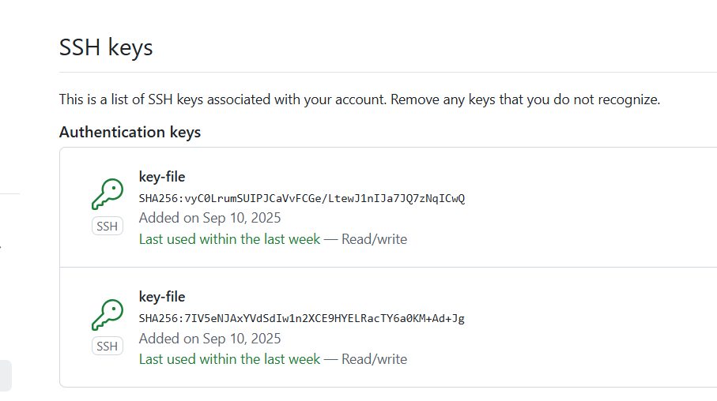

**9.GIT PUSH -U ORIGIN MASTER**

**Push the code to the central repository**

